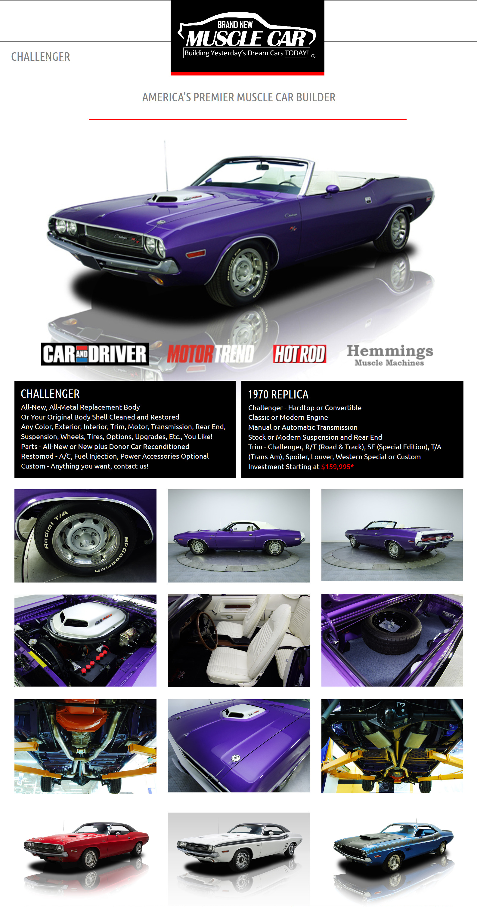

**A BIG THANK-YOU FOR THE INFORMATION**

**https://brandnewmusclecar.com/challenger.html**